|  |
| --- |
| IICT Construction Site Material  Management System |

|  |
| --- |
| Database Requirement Specification  for |

|  |  |
| --- | --- |
|  |  |

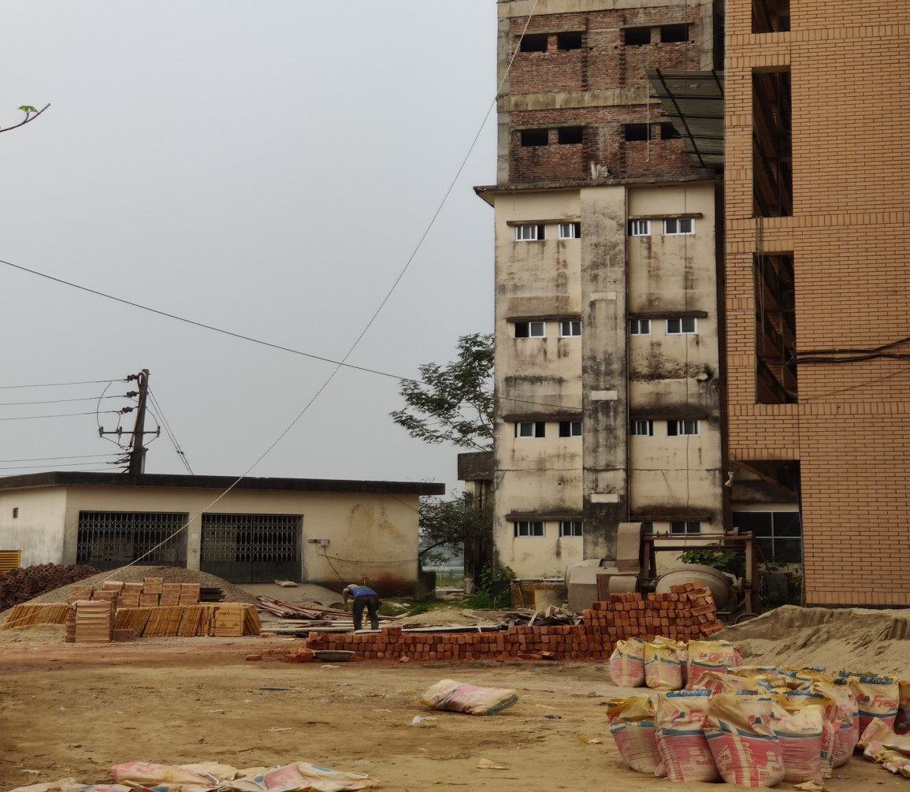

Course Name: Database Management System Lab

Course Code: SWE 328

Project Supervisor:

Dr. Ahsan Habib

Assistant Professor, IICT, SUST

Submitted By:

Team The TechNerds

Team Members:

1. Md Sadman Hafiz (Reg:2018831057)
2. Sanjana Afrin (Reg:2019831054)
3. Ashrafur Rahman Chowdhury (Reg:2019831070)
4. Shaikh Ifaz Aiman (Reg:2019831031)

Date Of Supervision:

29th March 2023

Contents

Type chapter title (level 1)1

Type chapter title (level 2)2

Type chapter title (level 3)3

Type chapter title (level 1)4

Type chapter title (level 2)5

Type chapter title (level 3)6

|  |
| --- |
| **LETTER OF**  **TRANSMITTAL** |

29th March,2023

Dr. Ahsan Habib

Assistant Professor,

IICT, Shahjalal University of Science and Technology, Sylhet

Dear Sir,

We have prepared the attached report on the Software Requirements Specifications of “IICT Construction Site Management System” application for your approval. This report describes the project requirements we've gathered so far.

The major objective of this report is to provide a synopsis of our results from our Project field work. This report contains the specifics of each process used to gather the requirements.

Sincerely yours

Md Sadman Hafiz

On behalf of

Team The TechNerds

Enclosure: Collected documents so far

|  |
| --- |
| Executive Summary |

IICT Construction Site Material Management System

In 2023, the construction project in our building was still being controlled manually, and we, Team The TechNerds, IICT, SUST students, were thinking about it. We have therefore chosen to totally automate the management of the entire construction site in order to reduce the stress on the staff working on our own building.

Our project intends to build a database that will allow workers to manage the entire building site almost entirely without paper.

Construction Site:

Construction site management is the process of organizing , planning, and monitoring the work being done on a construction site to make sure the project is finished on schedule, on budget, and in accordance with all applicable laws and safety requirements.

Project Idea Development:

Handling a building site manually can be difficult and intimidating. Handling a construction site management system manually can lead to a number of issues,

such as

* Lack of real-time data
* Safety concerns
* Ineffective communication
* Difficulty in managing resources.

In this situation, In order to streamline procedures, enhance communication, and boost productivity overall, a construction site database management system can be very helpful in managing construction site activities.

|  |
| --- |
| Brief Introduction |

|  |
| --- |
| Project Storyline |

Receiving contract:

It goes through some approval process from the proper stakeholder or Owners

Planning:

This involves developing a project plan that outlines the scope of the project, the timeline, the budget, and the resources required.

Site Preparation:

Once the project plan is in place, the site preparation process begins. This involves clearing the site, setting up the construction site office, installing temporary facilities.

Procurement:

The procurement process involves identifying and purchasing the necessary construction materials, equipment, and supplies.

Division of the Whole Project into Subparts:

According to IICT Construction Site Engineer, they divides the whole project into sub parts and contracts with the external service providers for the specific subtasks.

Quality Control:

This involves regular inspections and testing to verify that the work meets the required standards and specifications.

Project Management:

This includes managing the project team, coordinating activities, communicating with stakeholders, and monitoring progress against the project plan.

|  |
| --- |
| Basic Workflow |

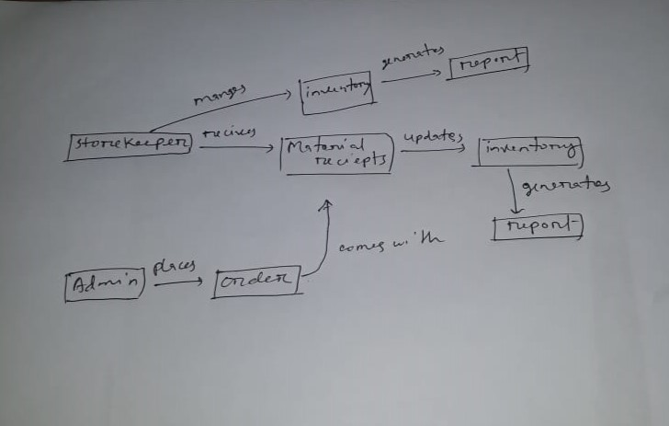

Figure :Basic Workflow of Construction Site Material Management

1. Generating Requision

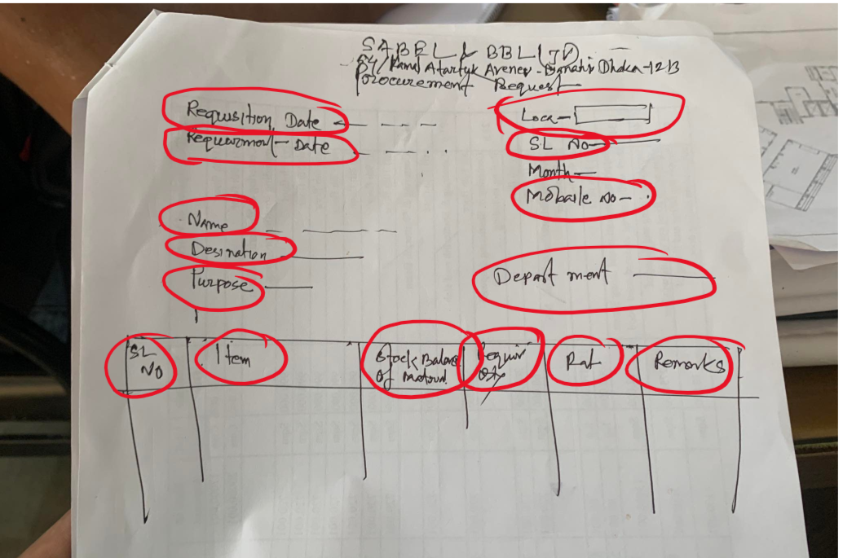

|  |
| --- |
| Basic Workflow(Details) |

Figure : Requisition Form

Entity Taken Form Here:

**RequisitionDetail**

**Attributes:**  
 -RequisitionDate

-RequirementDate

-Location

-SlNo

-Purpose

-Destination

-Rate

-Quantity

-Stock

-Remarks

-Contact

B.Making Order Details:

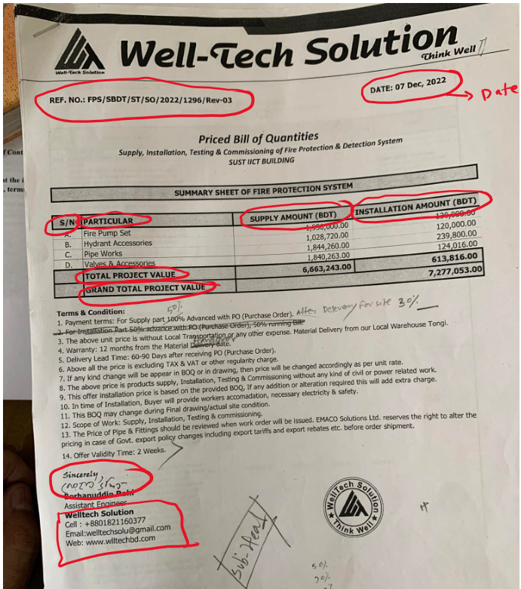

Figure :OderDetail From The Company

Entity Taken From Here:

**OrderDetail**

**Attributes:**

Date

Reference

SlNo

Particular

SupplyAmount

InstallationAmaount

Total

C.Recieving Materials:

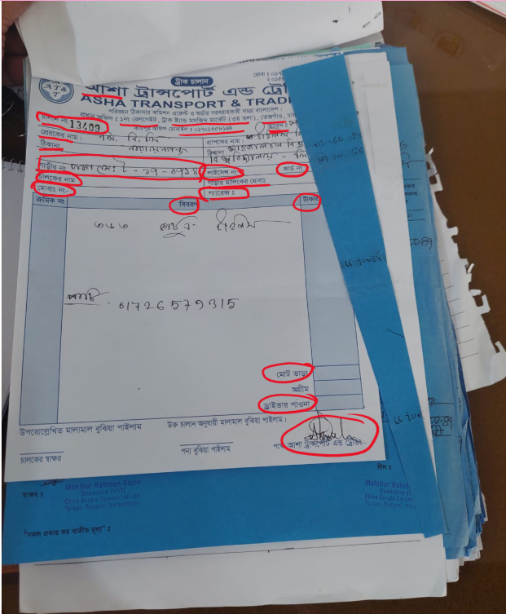

Figure :Materials Reciept

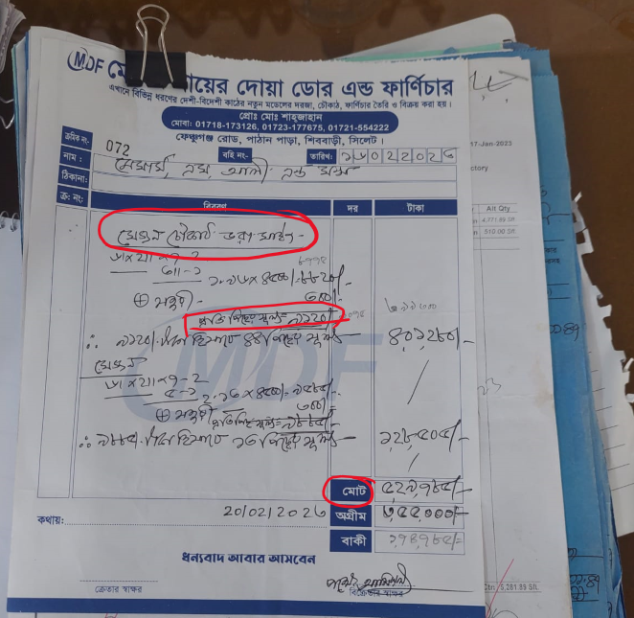Figure :Reciept

Entity Taken From Here

**-> Entity : Supplier**

**attributes:**

-Name

-Address

-Lisence

-ContactInfo

- Sign/remarks

**->Entity : Item**

**attributes:**

ID

Name

Rate

Price

Detail

**-> Entity: Driver**

**attributes:**

Name

contact

carOwner

RegiNo

Contact

**->Entity : Shipping Detail**

attributes:

Product_Name

Quantity

Rate

Price

DriverInfo

Date

Status

C.Updating Inventory:

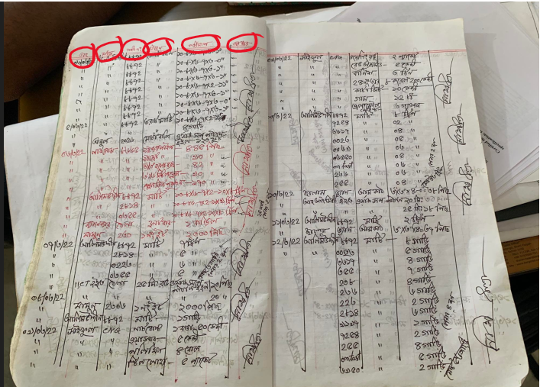

Figure :Updating Inventory1

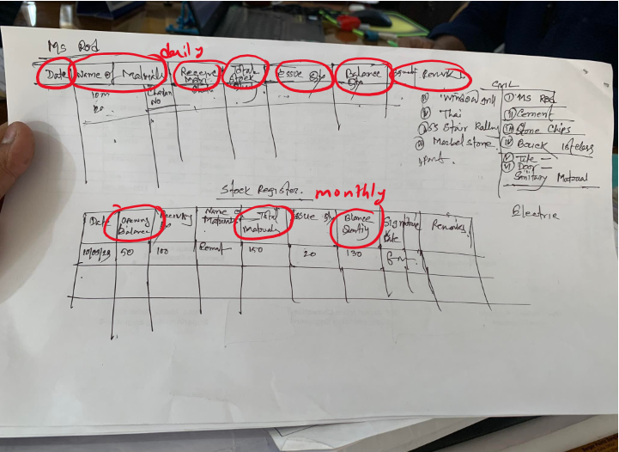

Figure :Updaing Inventory(Daily And Monthly)

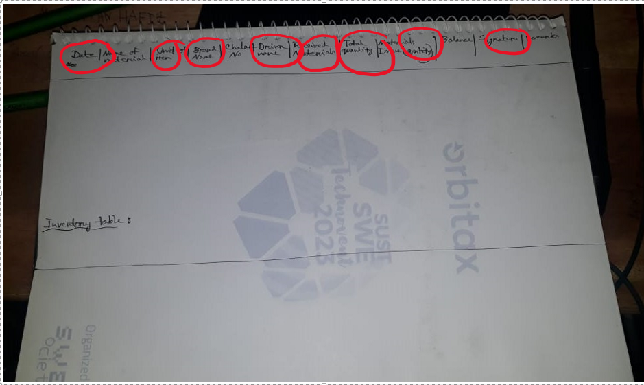

Figure :More Detailed Update

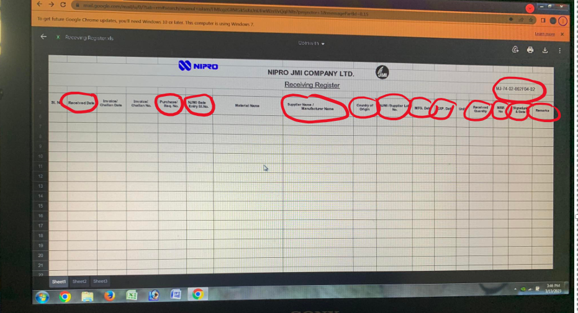

Figure :Basic Inventory Update Form

Entity Taken From Here:  
**Entity : Inventory**

**Attributes:**

Date

AvailableStock

IssuedItemName

In/out

RecieptID

ChalanNo

PurchasedQuanity

MaterialBalance

ExpiryDate

Total Entities

1.Storekeeper,Admin

2.inventory

3.item

4.Order Detail

5.Supplier

6.Shipping Detail

7.Driver

8.Requisition Detail

**ER DIAGRAM of IICT Construction Site Raw Material Management**

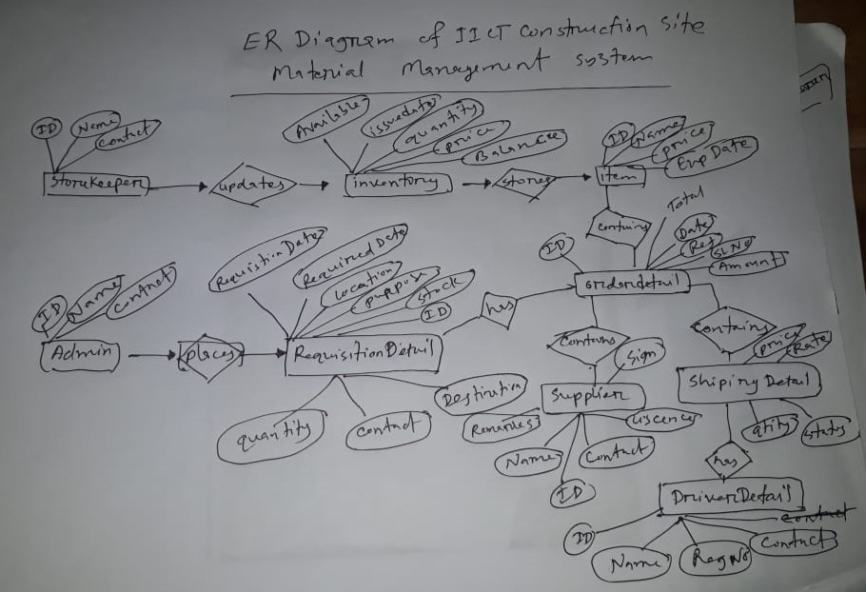

Figure :ER diagram

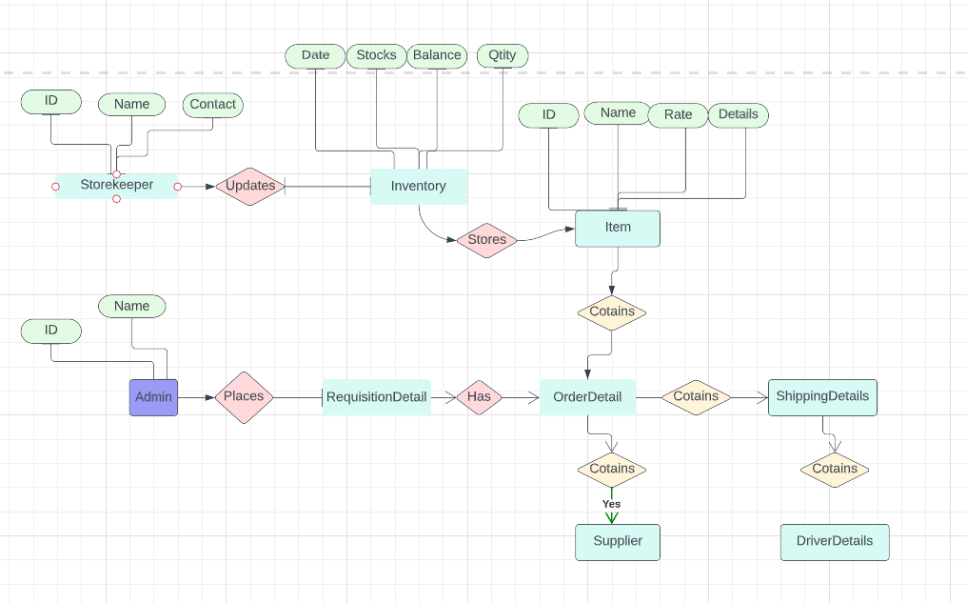

Figure : ER Diagram_2

Thank You!!

Any Question?